New Data Show no AI Jobs Apocalypse—for Now
The Tension: Data Tells Different Story Than Common Narrative
“Every day brings new breakthroughs in artificial intelligence—and new fears about the technology’s potential to trigger mass unemployment. With public anxiety growing, it can feel like the economy is already hemorrhaging jobs to AI.”
“But what if, at least for now, the data are telling a different story?”
“To find out, we measured how the labor market has changed since ChatGPT’s launch in November 2022. Specifically, we analyzed the change in the occupational mix across the labor market over the past 33 months. If generative AI technologies such as ChatGPT were automating jobs at scale, we would expect to see fewer workers employed in jobs at greatest risk of automation. Our data found the opposite”

Findings: Job Stability, Not Disruption
“In a new report from the Budget Lab at Yale, we share our findings of a labor market characterized broadly by stability, rather than disruption, since ChatGPT’s release. Despite fears of an imminent AI jobs apocalypse, the overall labor market shows more continuity than immediate collapse. The percent of workers in jobs with high, medium, and low AI “exposure” has remained remarkably steady over time. (Jobs that are highly “exposed” to generative AI technologies have the highest percentage of tasks that ChatGPT can be used for to save significant time.)”
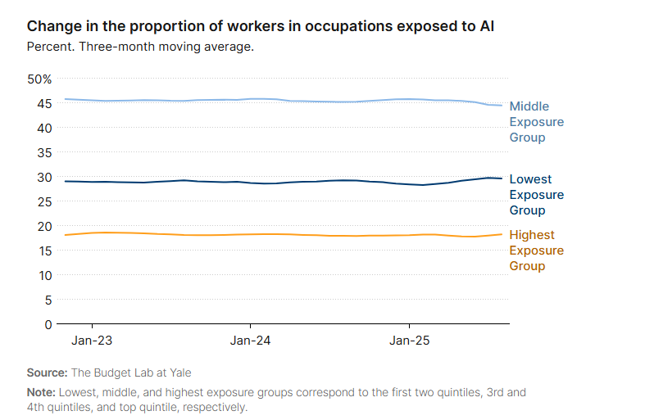
A Caveat
Transformative Technologies Gradually Cause a Revolution
“These patterns might surprise those expecting rapid labor displacement due to AI. While the results contradict the most alarming headlines, they are strikingly consistent with past precedent. Even transformative technologies such as the computer and the internet took decades, not mere months, for their impacts to fully materialize in the workplace. That’s because technology adoption requires complementary investments, cultural shifts, and regulation.
Generative AI has followed a similar trajectory in its first few years.”
“Overall, the pace of labor market change following ChatGPT’s launch nearly three years ago appears consistent with historical trends. AI’s early stages look less like a revolution and more like a familiar, gradual evolution.”

Early Career Workers at Risk
“These findings do not suggest that AI hasn’t had any impact at all over the last three years. Our analysis complements and is consistent with emerging evidence that AI may be contributing to unemployment among early-career workers. (It could also be consistent with evidence that a weakening labor market is hurting those same workers.) Our paper differs from more granular analyses that detect occupation-level impacts on isolated jobs or subpopulations—e.g., studying if writers or translators have lost jobs. There is still considerable uncertainty about AI’s early impact on these narrower sets of jobs and workers, which might be harbingers of wider labor market disruption in the future.”
“Our data show stability, not disruption, in AI’s labor market impacts—for now. But that could change at any point. Generative AI may well join the ranks of transformative, general purpose technologies, but it is too soon to know how disruptive it will be, or at what pace.”

